**Topic: Network Analytics**

**1) Use the flights_hault and connecting routes datasets to find betweenness, closeness centrality, page rank, directed and undirected graphs.**

**Dataset: Flights_hault**

**column names:**

**ID","Name","City","Country","IATA_FAA","ICAO","Latitude","Longitude","Altitude","Time","DST","Tz database time"**

**Dataset: Connecting routes**

**column names:**

**"flights", " ID", "main Airport","main Airport ID", "Destination ", "Destination ID", "haults", "machinary"**

**Data Preprocessing :**

1. Loading the dataset of flights_haul
2. As there are no proper column names, the new columns are given to the dataset
3. Loading the dataset of flights connecting routes
4. In this dataset as well, there are no proper column names, the new columns are given to the dataset

**Graphical Visualization:**

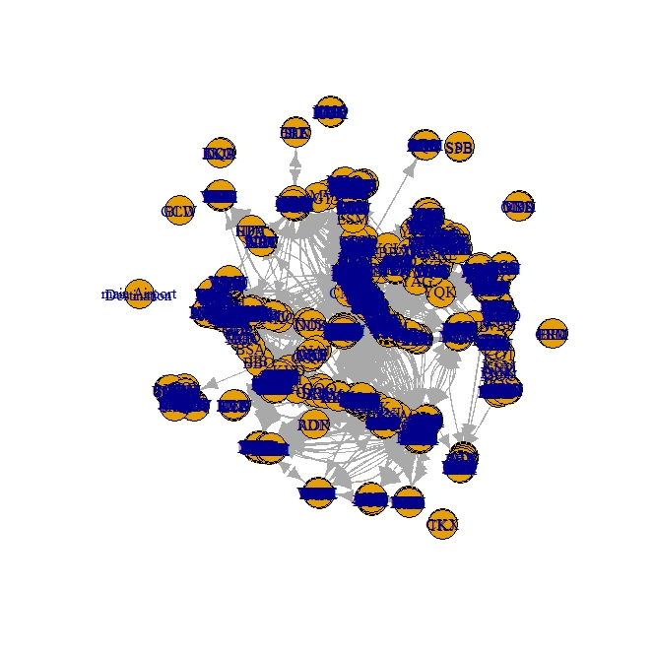

1. Using the function **vcount** we can see how many airports there is the network, here it shows that **3427** airports are available in this network.
2. With the help of **ecount** function, we can come to know that there are 67664 connections in the network.
3. With the help of **degree** function, we can clearly say that Atlanta airport has most flight incoming with the count of 911 flights and the given airport id is 3584.
4. With the help of **degree** function, we can clearly say that Atlanta airport has most flight out going with the count of 915 flights and the given airport id is 3584.
5. With the help of closeness function, we can find out which of the airport is close to most of the airport, here FRA is the closet airport with closeness value of 0.017 with the airport code 338.
6. Using betweenness function, we find that LAX as the most common routes and hence LAX is the international hub for all the points in center
7. Taking the degree, closeness and betweenness centralities below are the main airports

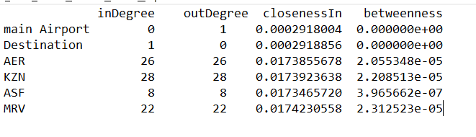

1. Below are the correlation of the centralities

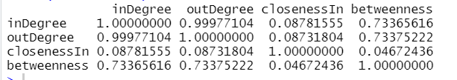

**Pair Plot for closeness and betweenness:**

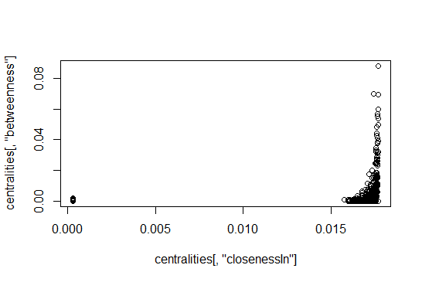

1. Using eigen centrality function, we say that Atlanta is the most important airport with eigen value 0.27
2. Using page rank function, we say that Atlanta is ranked as the best airport in google page rank system

**2) Business Problem: Three data sets of social media networks are attached.**

**- plot circular graph**

**- Star Graph for the three data sets**

**- Check for its nodes and directed and undirected graphs**

**Draw your insights on the data.**

**Ans:**

**Graphical Representation of Facebook**

**Star Graph:**

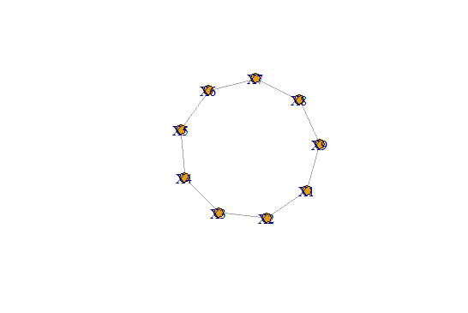

**Circular Graph:**

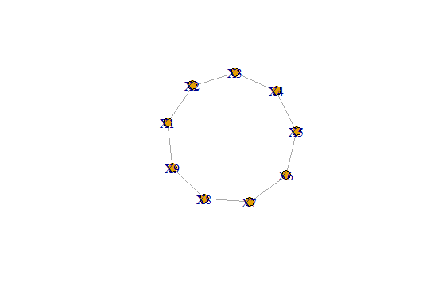

**GNP Graph:**

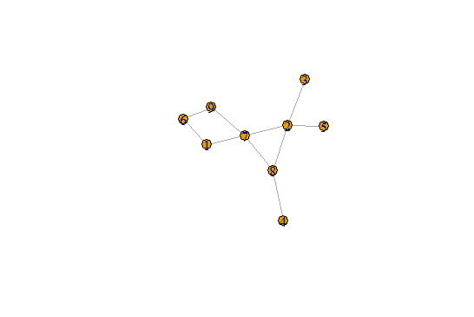

**Instructions:**

**1. Business Problem**

* 1. **Objective**
  2. **Constraints (if any)**

**Using R and Python codes perform:**

**2. Data Pre-processing**

**2.1 Data cleaning, Feature Engineering etc.**

**3. Exploratory Data Analysis (EDA):**

**3.1. Summary**

**3.2. Univariate analysis**

**3.3. Bivariate analysis**

**4. Model Building**

**4.1 Build the Network model on the given data sets.**

**4.2 Perform the Network Analytics.**

**4.3 Model(s) Improvement (Try with different no. of clusters)**

**5. Result Share the benefits/impact of the solution - how or in what way the business (client) gets benefit from the solution provided.**

**6. problem statement information and data dictionary is given in next page.**

**Note:**

**The assignment should be submitted in the following format:**

* **R code**
* **Python code**
* **Code Modularization should be maintained**
* **Documentation of the modules (elaborating on steps mentioned above).**